1.   
Check for validity it should be 12 digits and allows on number and alphabet

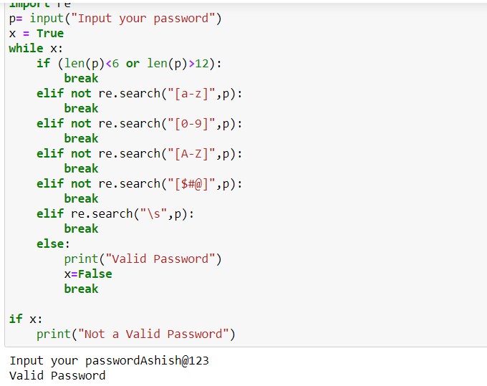

2. Read the input from command line Reference ID

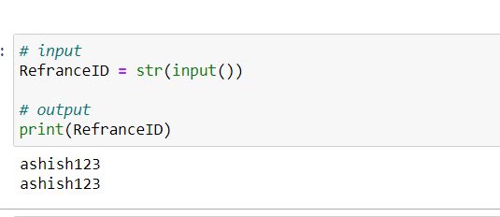

3. Encrypt the Reference ID and print it for reference

